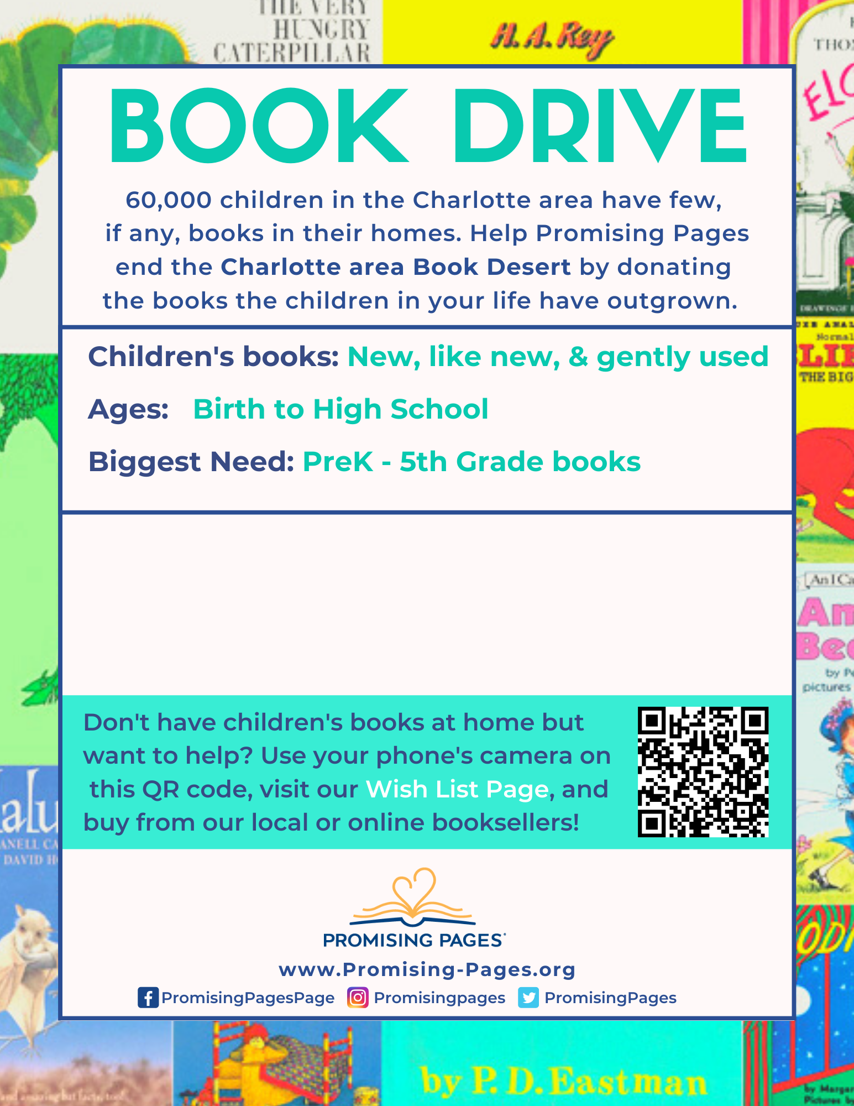

**(Group’s Name Here)**

**Book Drive Dates:**

**Collection Locations:**

**Book Collection Goal:**

**Contact Info:**